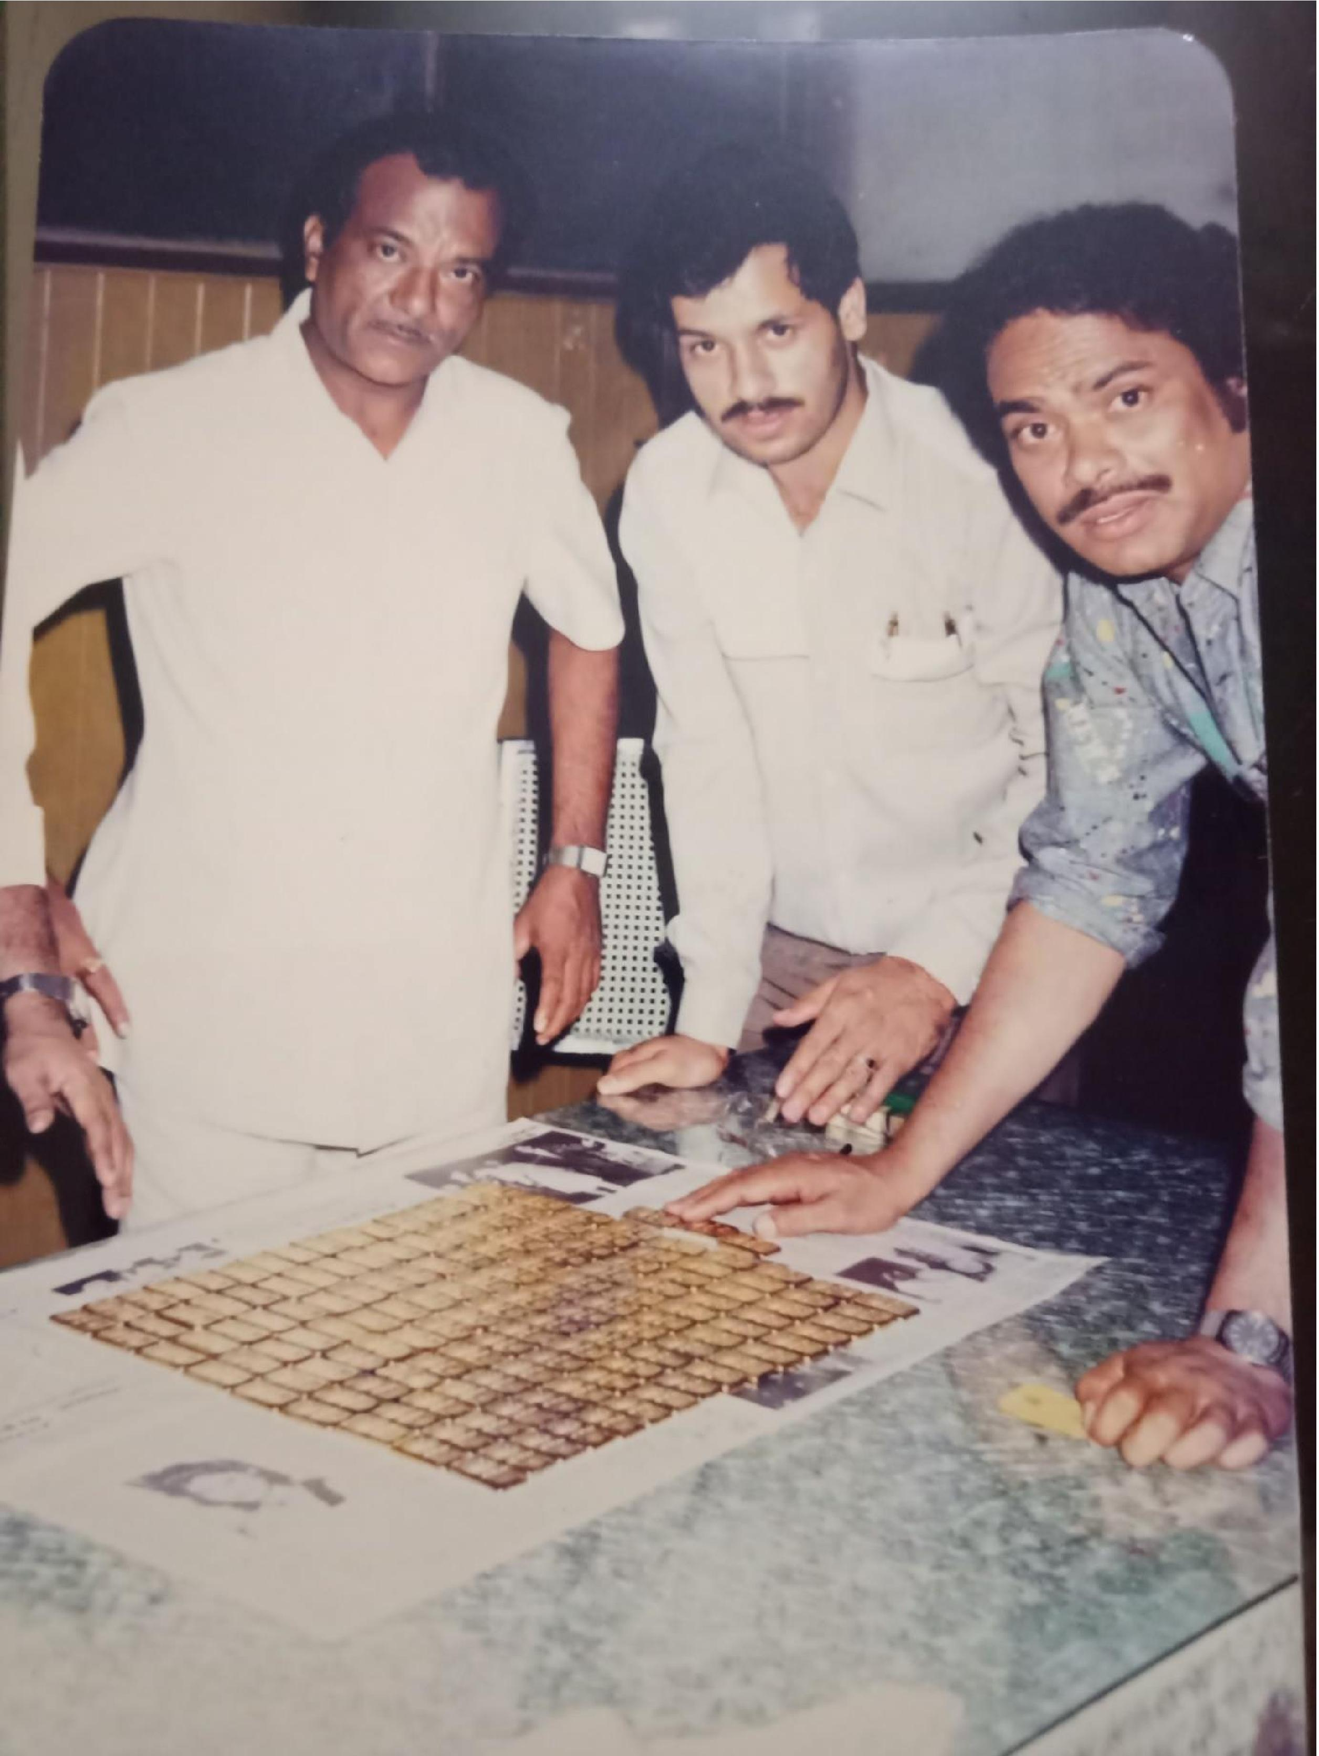

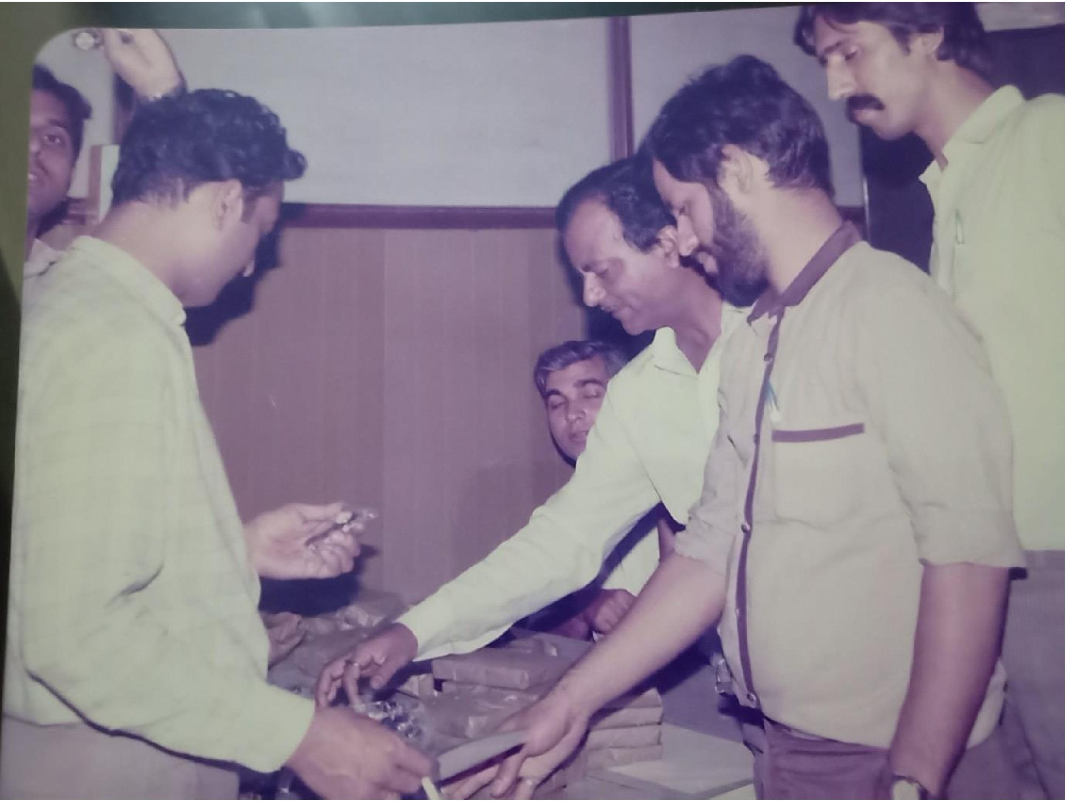

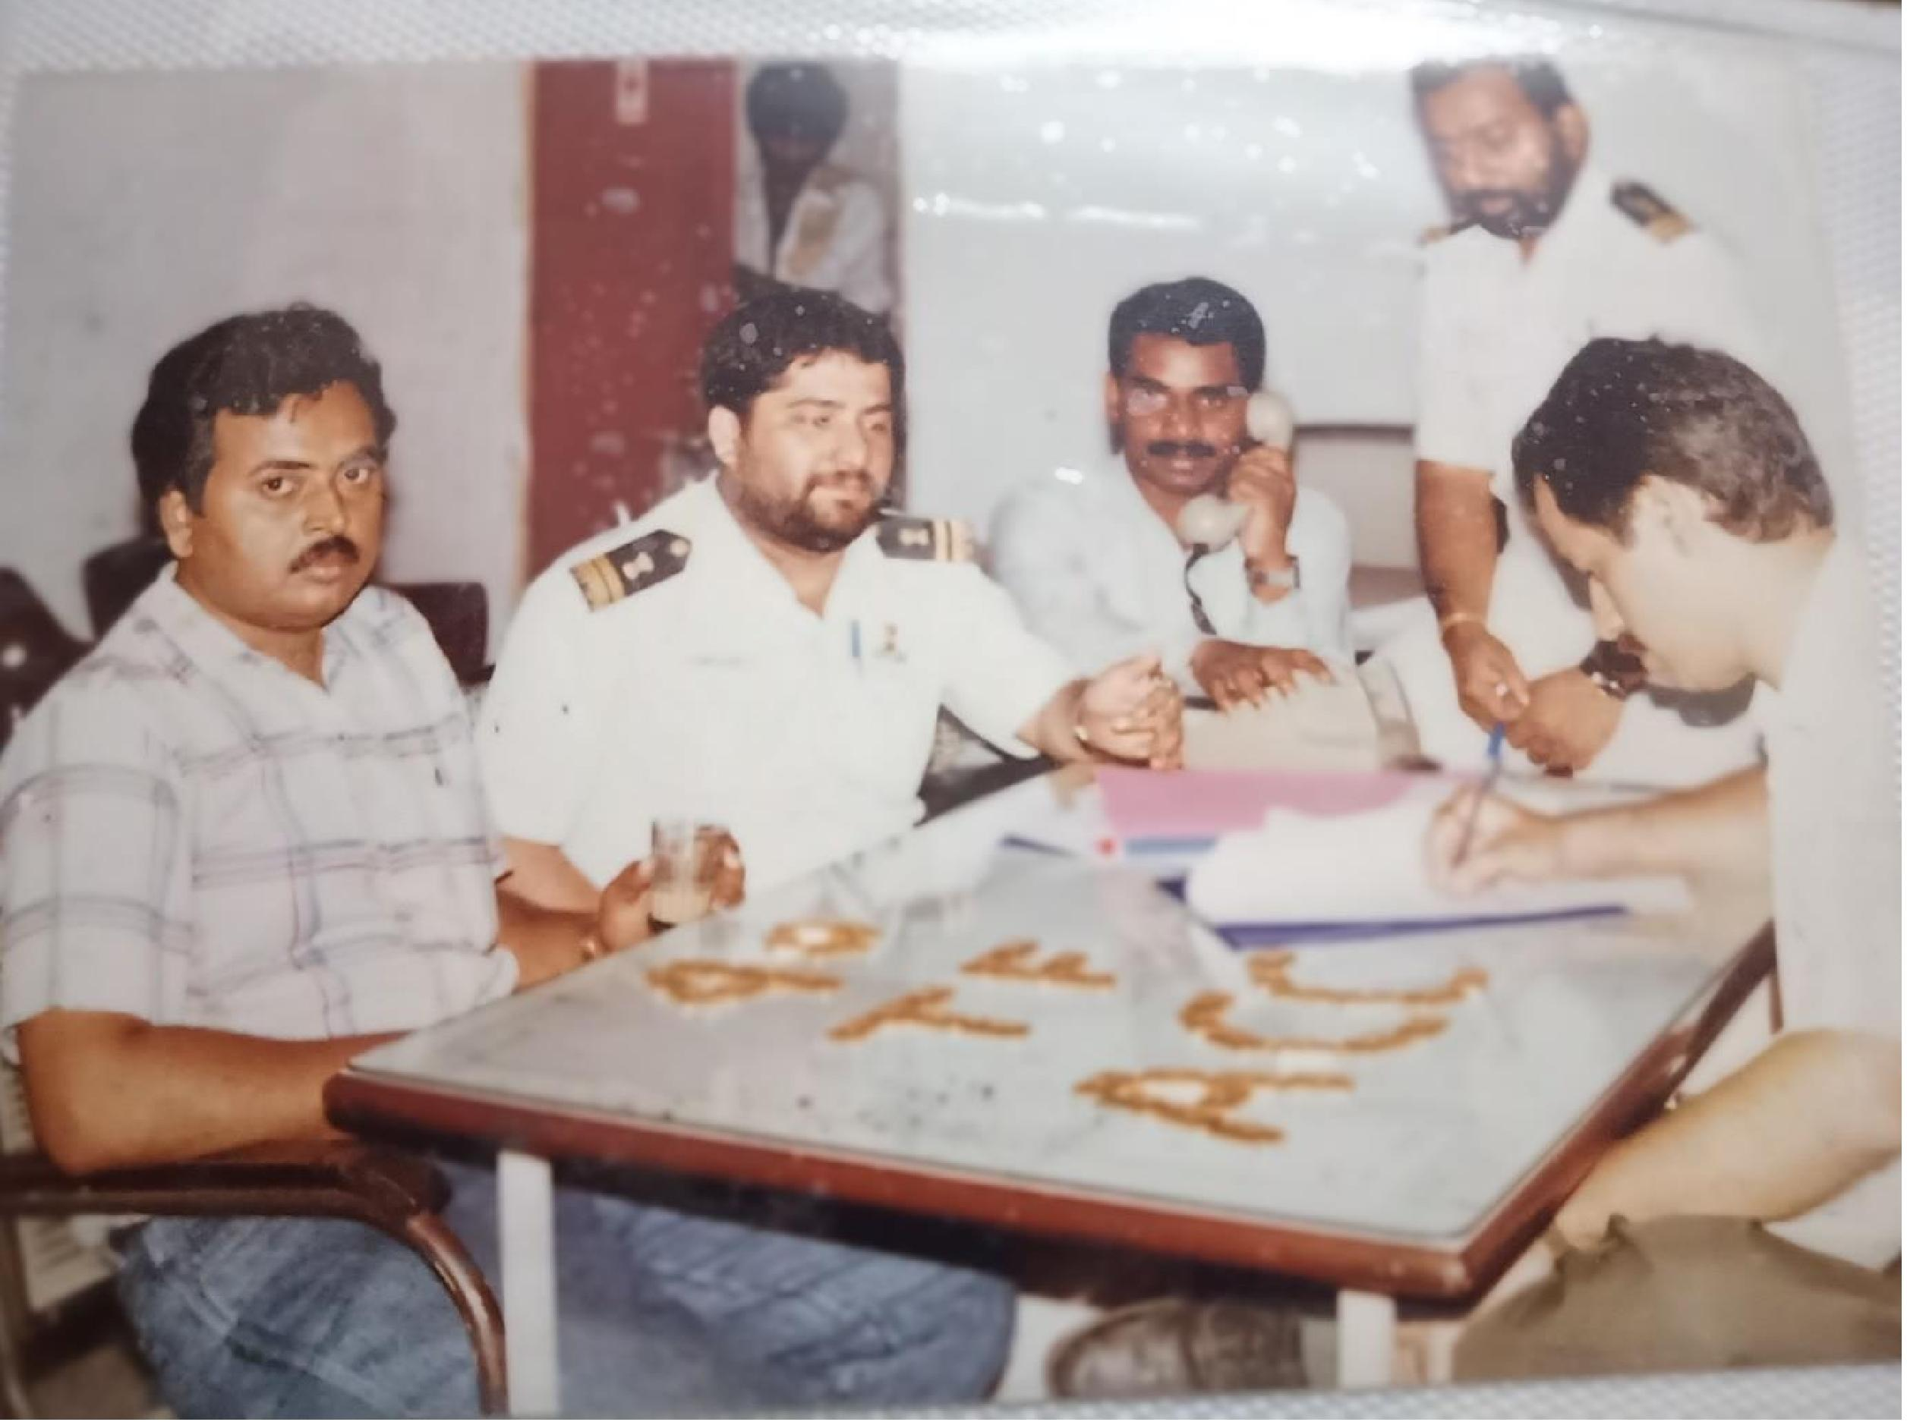

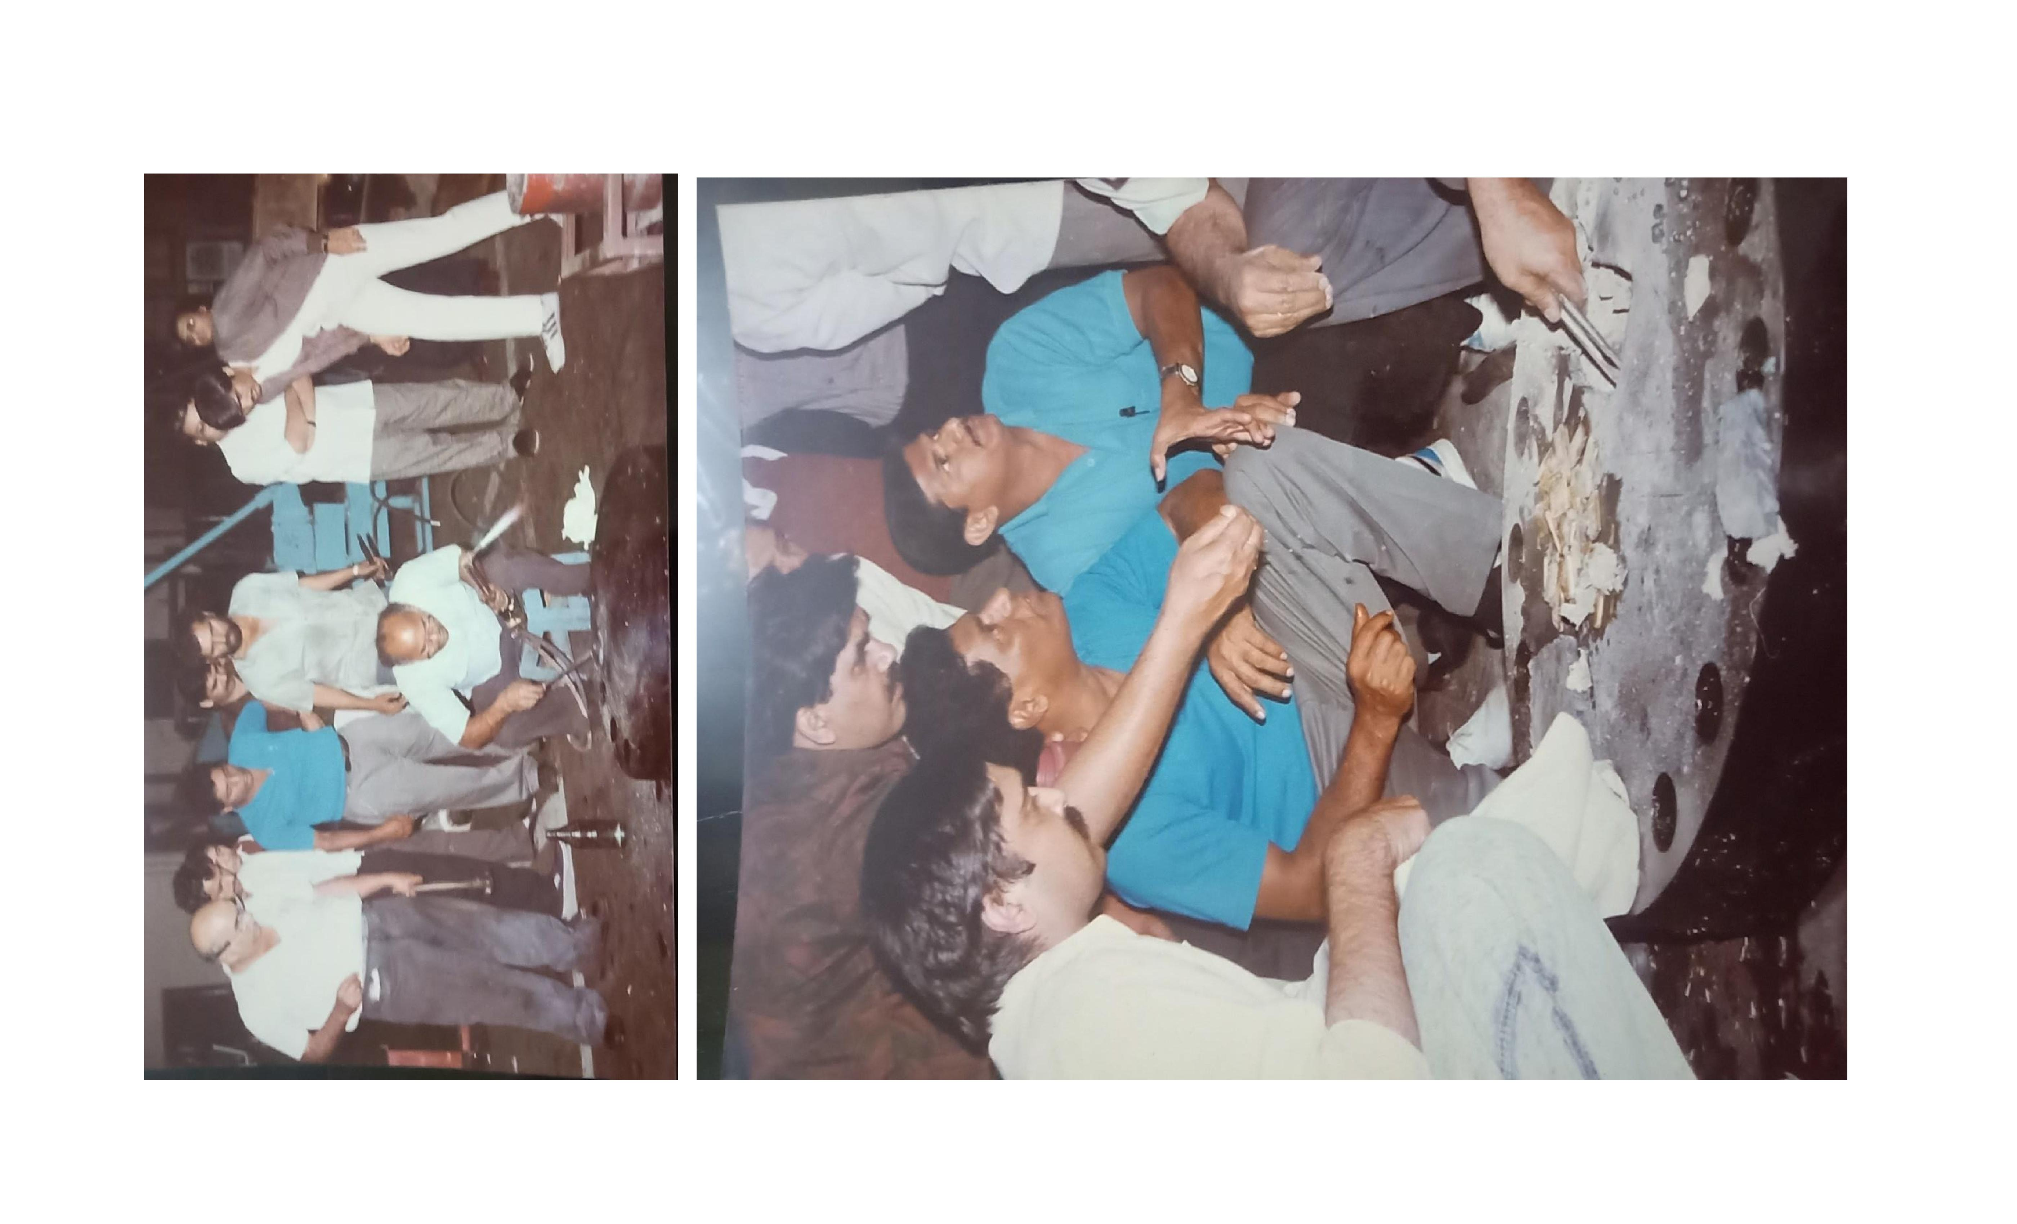

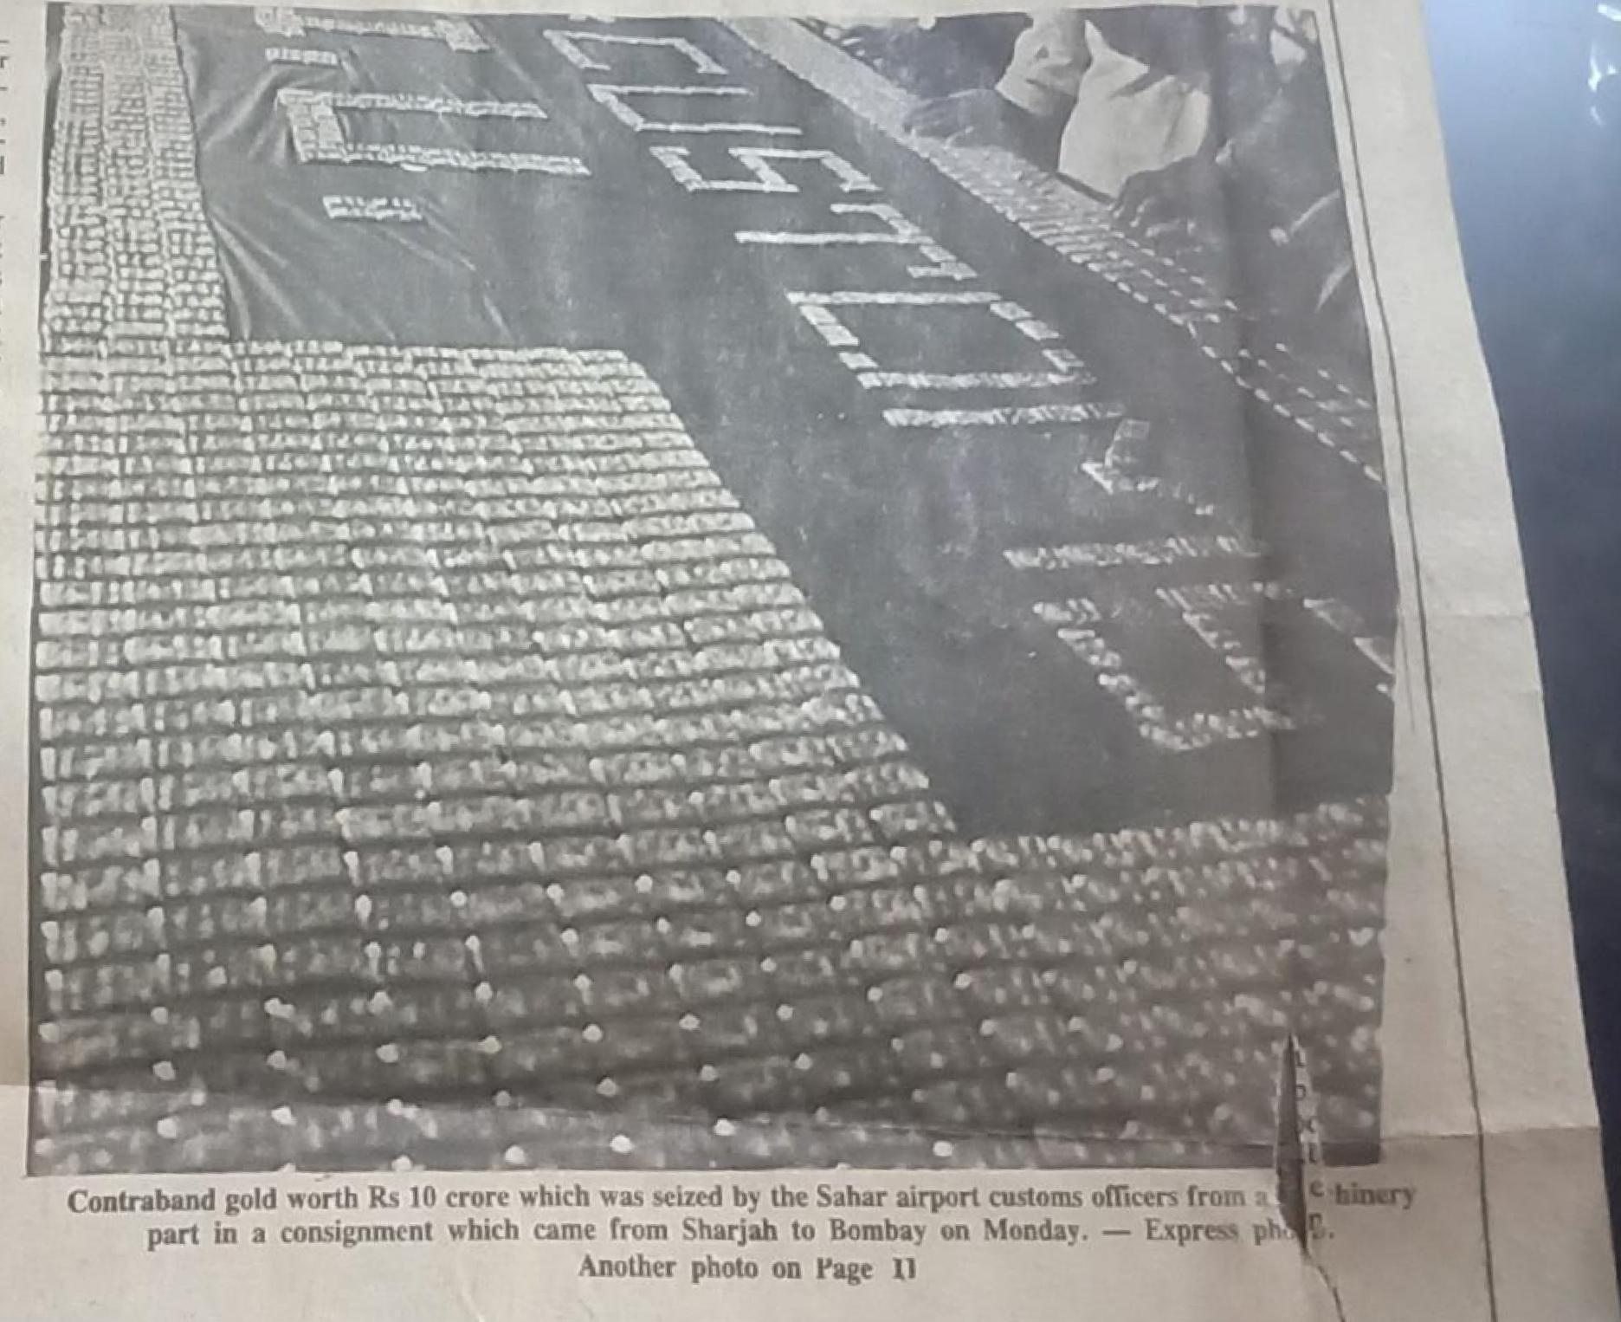

|  |
| --- |
| **Whale gA** haul Sahar  **ARRAll14, 414** go**l**d  **EXPRESS NEWS SERVICE** |

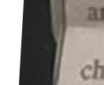

BOMBAY - In the biggest oier haul of contraband gold in the his­tory **of any airport *in*** the country, the Saha **International airport cus­toms authorities on Monday seized gold** worth **R5** 10.57 **crore.**

**The additional customs collector *Mr* Rajendra Prasad told ENS that *the*** gold concealed in 18 jackets **was *hidden* in a machinery part in a consignment from Sharjah. Acting on a rip off, the officers** of the **Air Intelligence Unit (AIU) of the air­port customs kept on a watch on the "suspicious" goods since the place of origin was** from **a "sensitive" airport. Though** the goods had ar­rived on a Gulf Air flight early on Monday, the officers kept a vigil almost throughout the day in their bid to find out the party to whom it was addressed to.

The Airway bill indicated that the company to whom the consignment was delivered was a Bangalore based fabrication company. Tele­phonic enquiries with them revealed that the company was a small scale unit with no interests at all in the import or export of any kind of machinery. The industry had a turn over of only about Rs 60,000 per annum and they vehemently denied

melt import.

The osier, then *decided* **to** *check the* **consignment. The de­scription** *of the* goods on the import documents was given as "Forged *Carbon* Steel Flange.- It weighed 575 kg, Mr Prasad said. All bids to cut open the machinery part, re­*sembling* a giant wheel proved un­saw.

unit to be *cut open* with an electric   
taken to the zha en Reddy.d hi re ni cn *eds* ai pt afhav abndr ac fabrication   
unitbe   
ri   
jcsuuThmaerss.offfivulcers of the MU, Jazdish,   
Narita, Supentendent I H Khan,   
head of *the* AIU Assistant Collector   
S L *Meena under* the guidance of

Mr Prasad, together worked under the overall supervision of the Cus­toms collector S A Khare in detect­ing the contraband.

**The** gold bars were hidden in jackets which in turn were packed in saw dust to prevent any untoward motion. The bars weighed 213.72 kg.

**I Wei *il c4,4*- 10.410/ 4** it **A *W.* . 741. . titempayloyeaftweaMIONPM**

**5 t.s.wbair•.,** ..:44.vuftatiworagmh, i S'aiat havolhollsaaor-A..1 ___„,rea,

**fl 4 aslig~ 4 tier 5 v•434 -1..-- -11'1-ral,**

**11114-111$4•A al s Amami A 14 . *g* 0,3%. r---dryuk**

**.14110401 MOM tawiliGalilks**

**Ileil *J* Wan !Low* tumw,A 1.404/111%/6C,ik.erSh ORM I PO*" ■" 411.4~/~4POVAreahlMi4**

***lie It. 1 :* 41-14 I..* Mai Se fa*. A .411,6i4.104, 9A**

**IA**

**ifigion 414111prAi444,4•11,1 4**

**rAilipait4f aal g ir 1 .0 !ri° WW- 1;.b, ti"11AAP.44"1-X"k**

**I444100,14-44;:l , 4 % . ty 4 PrOlralt?**

**•**

**\*Xi hi 12\\y**

**41 = ., • ' '**

**. r.: ■11 II tita i ' ‘**

**I **Mao . lb WA •Lt , */441•10,* .• 1•II • 4.116,510,6,5, Wit**

**Livesabl41 4.0 , ♦ ...,.■ !•Ithe • *•41p,•5* 5.111115.10/.■.012%**

**AMU 1,...414,,stuwirao-aea.varwair.iaismoiaavemi**

**.31144 /14411...114,..41,..111,1*0.#4. !IA...IMO...Men. la, ir...f, •**

**N...**

Contraband gold worth Rs **10** crore which was seized by the Sahar airport customs officers from part in **a consignment which** came from **Sharjah to Bombay on Monday. —** Express ph

Another photo on Page 11

Sahar airport's biggest seizure was 750 gold biscuits of 10 toles each in 1988. The present seizure of gold is more than twice in number and more than three times in value in companson to the previous largest seizure of gold, customs authorities here said.

Reliable customs sources said that

**1,1/1 • -**

**.8 '10**

**1'40**

* **'**
* **0 a • •**
* **b" 411gist;**

**. 7.**

**17111**

**p .111,**

the large amount of ntraband

indicated that there **vier,** defitutly some 'big fish' in the Gull hick was involved. The seizures t udine the current one indicates that the smug­gling of gold to India has on

become lucrative what with th, price of the yellow metal spiralling up in the past one nu.•niti.

**c *Mary**

